(Approx. 1438 words)

Travel Routers
By Dick Maybach, Member, Brookdale Computer Users’ Group, NJ
November 2014 issue, BUG Bytes
www.bcug.com
n2nd (at) att.net

A travel router is a small, inexpensive wireless router that provides the following functions.
- It connects to a wired Ethernet port and provides secure local wireless service. If your hotel provides it, wired Ethernet service is faster and more secure than wireless service.
- It connects to a wireless network and provides local secure wireless service to several devices. Since the wireless network sees only one device (the router) this will lower your costs if the hotel charges per device. Even if there is no charge, hotels often require that you register each device connected; using the router means you have to do this only once.
- If you use 3G/4G wire area wireless Internet service, the router accepts a 3G/4G USB dongle and provides service to a local secure wireless network.
- It connects to a wireless network to provide local wired Ethernet service.

The photo shows a typical unit, a TP-Link TL-MR3020, which costs less than $40.

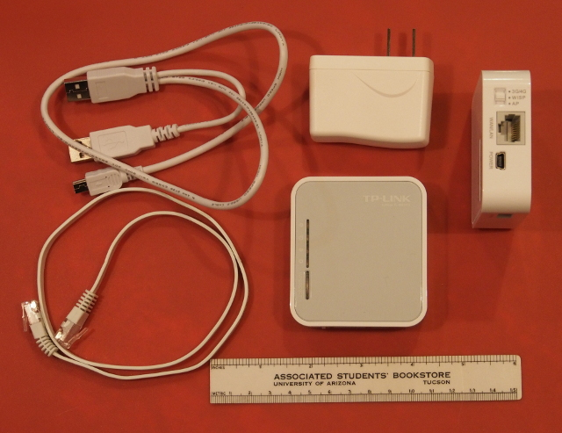

This unit includes the 3 by 3 1/2” router, a power supply, and short Ethernet and USB cables (the latter to power the device). There are two routers in the picture; the one on the right is on its side to show the connections and mode switch. Note that the USB power cable has a Y configuration, which allows you to power the router from two USB connectors on your PC. (Two are needed to supply enough current as not enough is available from just one standard USB port. When using the power supply, one of these will dangle.) The TP-Link power supply accommodates both 110- and 220-volt AC power, which is important for foreign travel. The total weight is just 5.5 ounces, so you can probably find room for it in your suitcase.

The devices small size results in some limitations.
- Its internal antenna and limited radio power limit its wireless range compared to a full-sized router. Expect good performance only over a range of a few meters, plenty for a hotel room but don't expect to access it from poolside.
- This unit has only one Ethernet connector. If it's connected to a wired network, it can provide only wireless service; if it's connected to a wireless network, it can provide service to only one wired device.
- The cables are short; if the AC power receptacle is more than four feet from the wired Ethernet one, you'll need an extension cord.

Different manufacturers provide travel routers with different feature sets: some have two Ethernet connectors; some have none; some combine the power supply and router; some have higher power and external antennas to improve the range; and some have internal batteries. You will have to do some research to get a unit that suits your particular needs.

Modes of Operation

A router connected to a wired Ethernet port and providing local wireless service is operating in wireless access point (AP) mode.

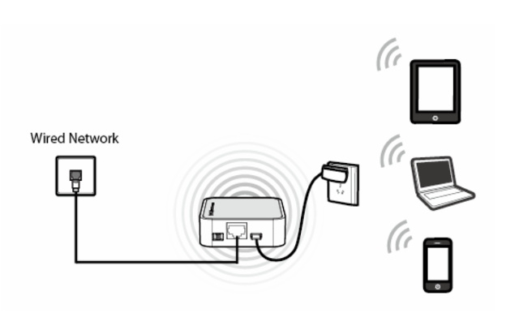

Here, the wired network assigns network addresses to all the devices. Usually, the local wireless network is secured using WPA encryption so only your devices can see the traffic on it, and the router includes a firewall, which further protects you.

A router connected to an external wireless network and providing local wireless (and perhaps wired) service is operating in wireless Internet service provider (WISP) mode.

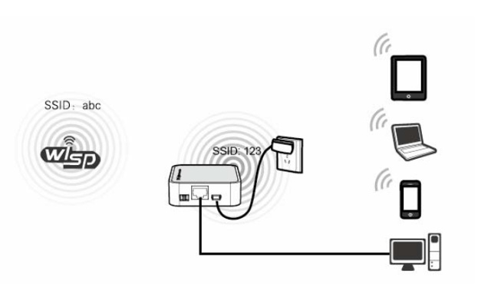

In the figure the external network has an SSID of “abc” and the local one has “123”. Although the network shown has four devices, the external one sees only the router. The local traffic is encrypted, and the router has a firewall; however, all the data on the external network is visible to every device connected to it. If you set the local SSID to be the same as that of the external network and use the same password (which you would never do at a hotel), the router acts as a range extender. But the device's low power and internal antenna will limit its effectiveness here. Finally, in this mode the device can provide wireless access to a PC lacking a working wireless adapter.

If you subscribe to wide-area 3G/4G wireless service and have a USB dongle for your PC, you can plug the dongle into a travel router to provide such service to several devices, as shown in the figure below.

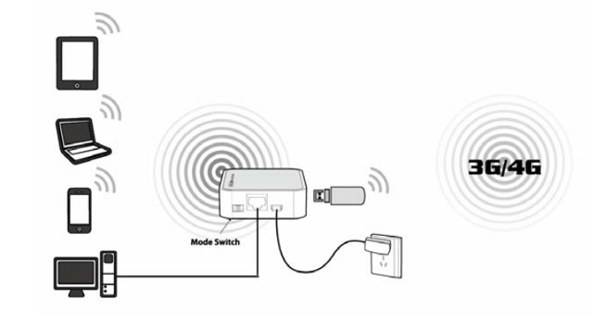

As in WISP mode, you have both local wired and wireless service.

Configuration

Most travel routers are configured by using an Internet browser to access their administration page, usually at http://192.168.0.254 or http://192.168.1.254. A few require special software, at least for the initial set-up. This can be a serious limitation for Linux and OS X users if only a Windows version is available.

You should complete the configuration before you leave home. Expect to spend some time experimenting, especially because the manuals are frequently out of date. You don't want to be stuck in a hotel room, while your family is romping on the beach at Maui, or worse, you don't want to mis-configure your network so that it's not secure. At a minimum, you should change the administrator password, enable encryption of the local wireless network, and configure your devices to work with the router. You should also become familiar with the procedure to set up access to an external wireless network.

The screen-shot shows the administration page for my TP-Link TL-MR3020 router.

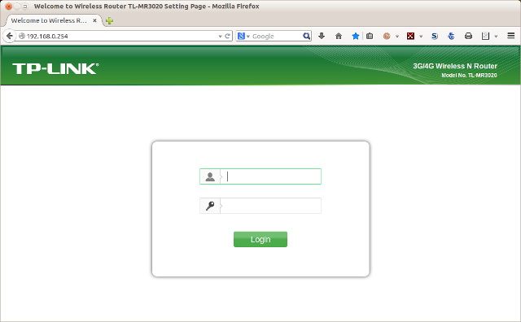

The default user-name is “admin” and the default password is also “admin”; if course, you'll change both before you leave home. Once you log in, you'll see the summary administration screen.

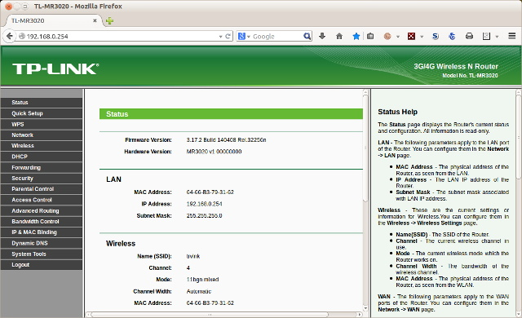

As you can see from the cursor bars, only a portion of the page is visible here. The left panel allows you to navigate among the various pages, and the right one provides help. The equivalent screen for your router probably has a different appearance, but the information will be similar. When you select a menu item in the left panel you will usually see sub-items, as shown in the screen-shot below for a menu accessed from the Wireless item.

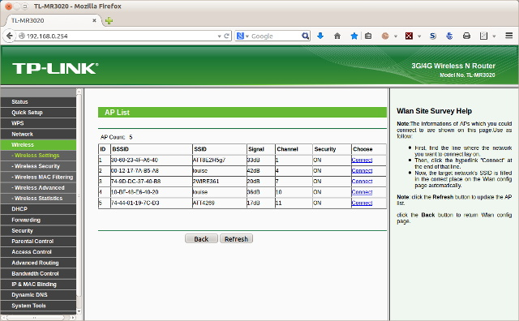

This is a very useful page, as it shows all the available external wireless networks and their signal strengths. (Note that two items have the SSID "louise". These show the two APs in our house, one with a relative power of 42 and the other with 36 dB. The 6 dB difference is equivalent to a factor of four in power.) You would use this page to select the proper external network.

Before you leave home, you should update the router's firmware; on this unit, updating is one of the system tools. In my experience, the firmware supplied with a new unit is seldom the latest version. You depend on the router to provide security, and keeping it up to date is as important as for your anti-malware software, especially since you will often use it in a hostile environment.

Security

When you use a public wireless system, such as that in a hotel, all data packets are visible to everyone using that system. Each packet has an address, and normally, every station will ignore all the packets not addressed to it. However, software is available that captures every packet on the network, and when you use such a network you should behave as though someone is monitoring all your data, both sent and received.

Using a travel router in WISP mode prevents outsiders from seeing your PCs, but they still can access the data the router exchanges with the wireless base station. You should thus use Tor (see the article in the February 2011 Bytes, available at http://www.bcug.com) or a similar secure communication utility. On a wired network, the only station receiving your packets is the one to whom they are addressed; similarly, only you can see the packets addressed to you. Thus, if your hotel provides wired Ethernet service, you should use that. In addition, wired networks almost provide much higher throughput than do wireless ones. Despite the higher security of wired networks, I recommend you use Tor (or something similar) on them as well.

Remember that you are operating in a hostile environment, even though your local wireless network is secure. You should increase the security of your PCs above that when you are operating at home. For example, on a Windows 7 PC, navigate Control Panel > Network and Internet > Network and Sharing Center and select the network you will use when connected to the travel router ("Network" in the screen-shot below) and change this to "Public Network". Linux and OS X users may wish to tighten the settings of their firewalls.

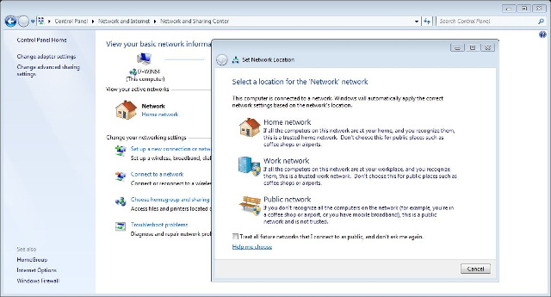

Dick Maybach

